Solutions to Exercises 2.

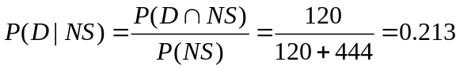

So 21.3% of people with NS employment status default, 78.7% are OK.

Again if we reject everybody with NS employment the defaulting rate will be:

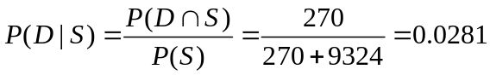 about the same as with the other criterion

If reject all that are NS then reject 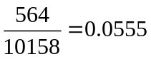 about 5.6% of applications are rejected.

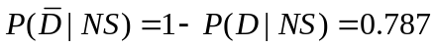

So still the vast majority of applications that are rejected would have been OK

If the use the criterion they will accept 0.9445 of the applications.

0.028 of these will default - lose 10000 0.972 will gain 2000

So money made = (0.972*2000-0.028*10000)*0.9445*N=1571.65 * N

This is better than not using the info.

Using the two tests.

Grant if pass both

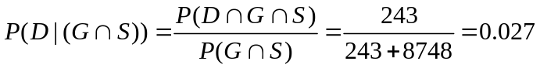

This is only a tiny bit less than using one test (either) !

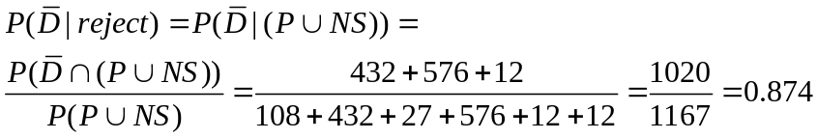

87.4% of rejected applications would be OK.

Grant if pass either

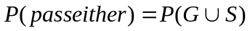
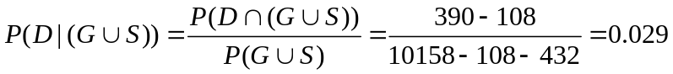

As an alternative way of calculating these probs.

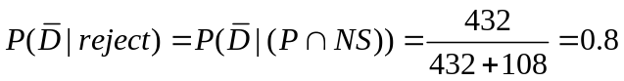

Really applying two tests is no different to applying either – the second test is useless!
Both tests carry similar information.
This suggests they are not independent. (even conditionally)

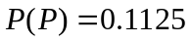 from page 2.
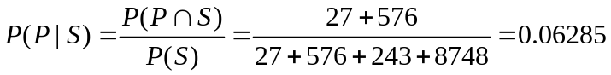

As these are not equal the events are not indpedent.

Note I could have used G and/or NS instead of P and S.

